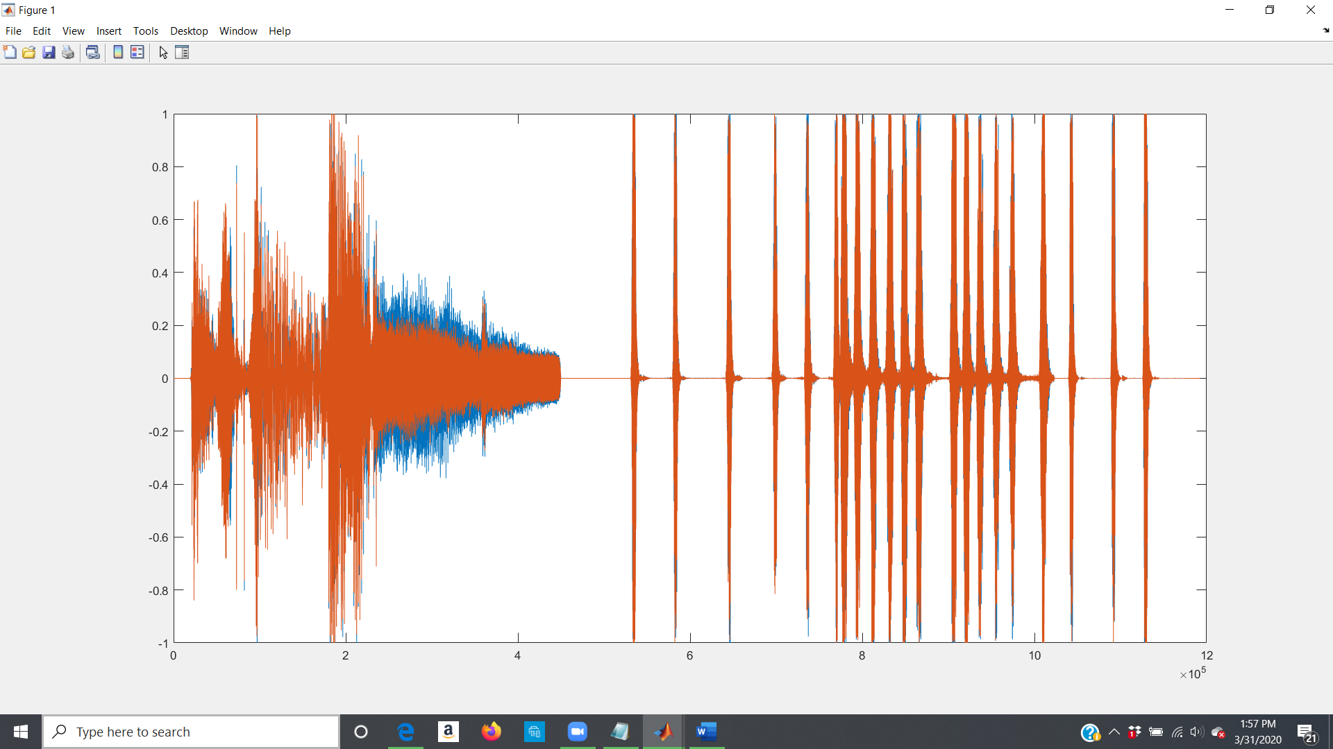

JUST DOG BARKING ^^

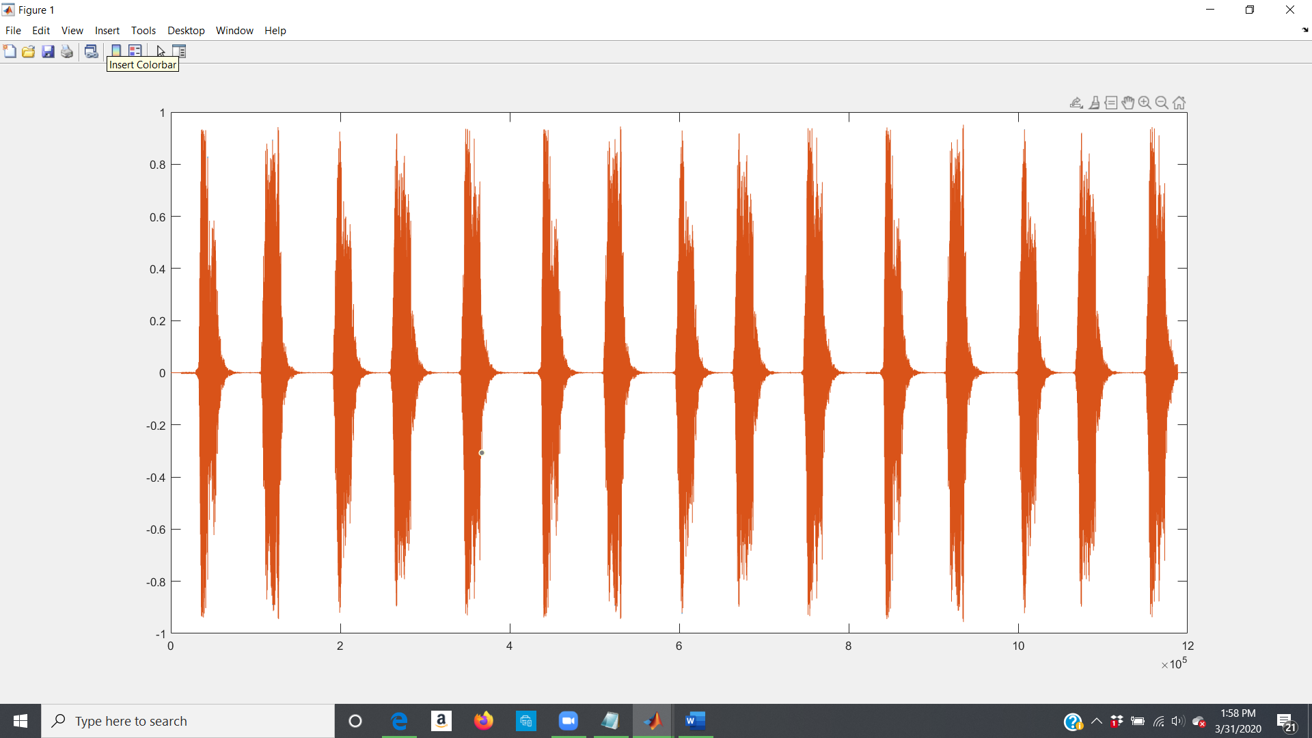

DUCK QUACKING^^

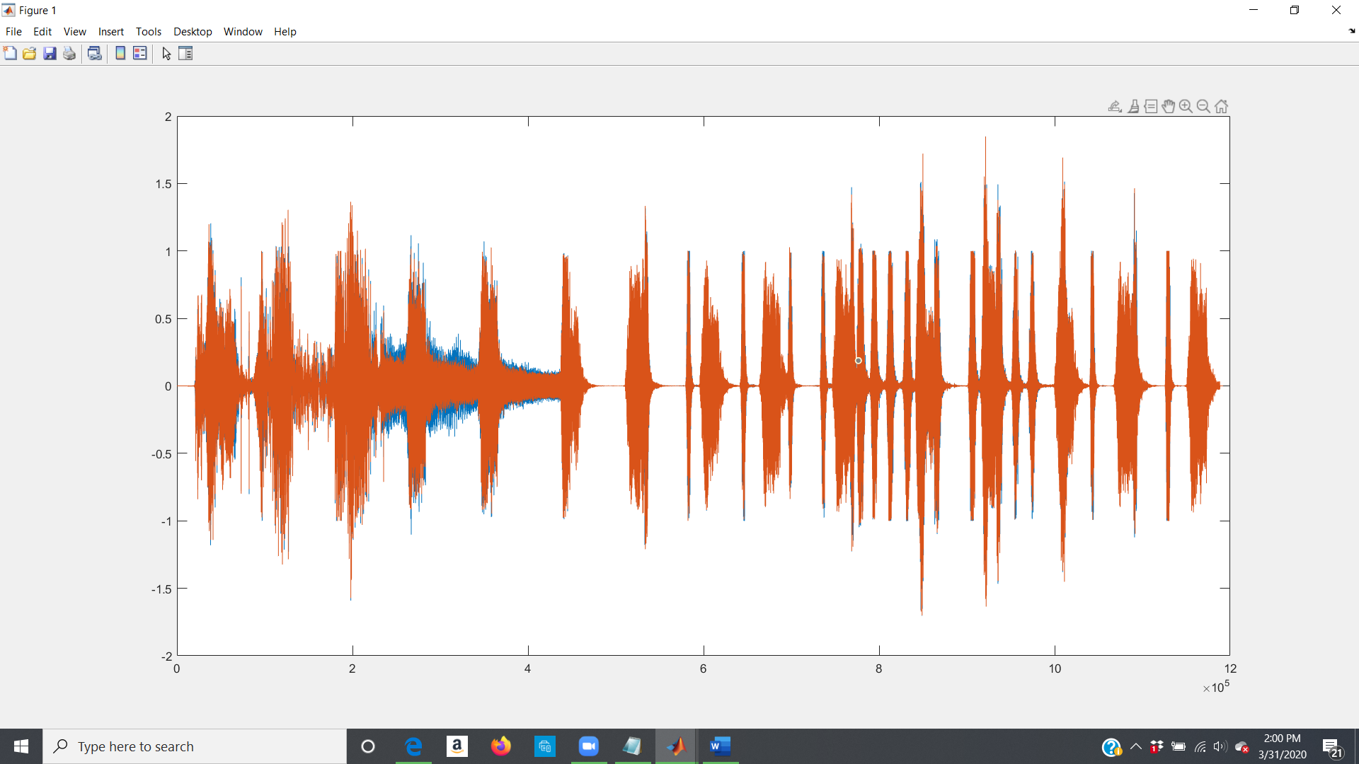

ADDED TOGETHER^^

CODE:

%-- 3/31/2020 1:22 PM --%

[a,fs] = audioread('DOG.mp3')

[b,fs1] = audioread('DUCK.mp3')

b2 = imresize(b,[1191792,2])

c = b2+a

plot(c)

figure clear

plot clear

clear plot

plot (c)

clear plot

plot(a)

clear plot

plot(b2)

clear plot

plot (c

plot (c)

player1=audioplayer(c,fs)

play (player1)